Instruction:
Complete all questions in 2 hours.

- Construct 4-bit Serial In parallel Out shift register using D- flip flop. Explain the Working mechanism of the circuit taking Serial input 0101. Also, draw the timing diagram according to the given input.
- Design a 3-bit counter using Toggle D flip flop and draw the timing diagram.
- Build the following circuit using LogSim / CircuitVerse and fill in the truth table showing the value of the two outputs for all input conditions. (remember a 3 input AND gate can be constructed from 2, 2 input AND gates)
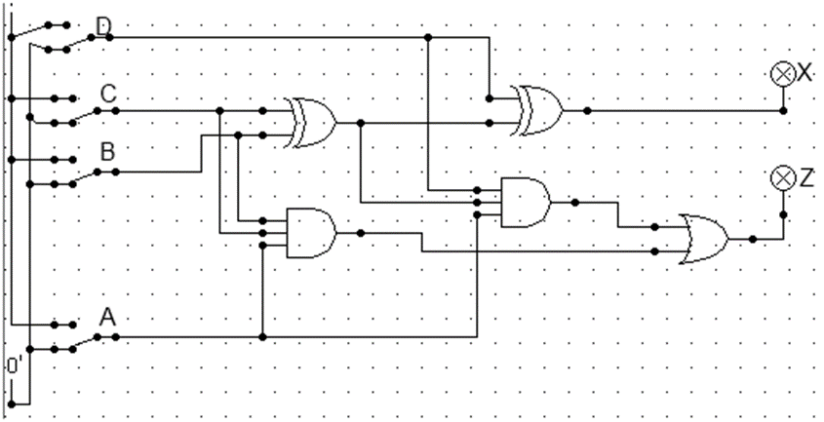

A | B | C | D | X | Z
0 | 0 | 0 | 0
0 | 0 | 0 | 1
0 | 0 | 1 | 0
0 | 0 | 1 | 1
0 | 1 | 0 | 0
0 | 1 | 0 | 1
0 | 1 | 1 | 0
0 | 1 | 1 | 1
1 | 0 | 0 | 0
1 | 0 | 0 | 1
1 | 0 | 1 | 0
1 | 0 | 1 | 1
1 | 1 | 0 | 0
1 | 1 | 0 | 1
1 | 1 | 1 | 0
1 | 1 | 1 | 1

In your own words, describe the function of the above circuit. How did you come to this conclusion? Look very carefully at the truth table and compare it with others we discussed in the lectures. As a final hint, look at how we turn one mathematical operation in logic into another.
- Using the last 4 unique digits of your student number as input, e.g. 0791377 would be 9137, design and build a password circuit (a circuit with a single output that lights an LED for your unique input pattern in binary) using LogSim that will give a true output when your number, expressed in a suitable binary form, is present on the inputs and 0 for all other 4 digit numbers between 0000 and 9999. Switches will therefore be needed for all inputs.
To get you started:
- Decide how to represent your 4-digit number in 1’s and 0’
- Put a switch for each binary input.
Thank you.

